CHAPTER 5: Chemical reactions
Worksheet 5.4

Precipitation
Student: Class:

Observing precipitation
1. The following photograph shows the result of adding a colourless solution of lead nitrate to a colourless solution of potassium iodide in a test tube.
Photo: Lindsey Moore/ Shutterstock.com | 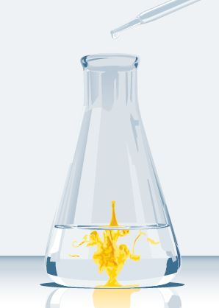 | (a) A yellow precipitate forms. Define the term ‘precipitate’.  (b) The beaker is allowed to stand for 1 hour. What will happen to the precipitate in that time?
(c) Name the compound making up the precipitate.

(d) Write a word equation for the reaction.

Predicting precipitation
2. The following table provides information on the solubility of various salts in water.
Anion | Soluble | Slightly soluble | Insoluble
Nitrate | All | None | None
Chloride | Most | PbCl₂ | AgCl
Sulfate | Most | CaSO₄, Ag₂SO₄ | BaSO₄, PbSO₄
Carbonate | Na₂CO₃, K₂CO₃, (NH₄)₂CO₃ | None | Most
Hydroxide | NaOH, KOH, NH₄OH, Ba(OH)₂ | Ca(OH)₂ | Most
Use this information to predict whether a precipitate will form when the nominated solutions are mixed. If a precipitate forms, name the precipitate.
(a) Lead nitrate solution + sodium sulfate solution.

(b) Copper(II) sulfate solution + potassium hydroxide solution.

(c) Barium chloride solution + calcium nitrate solution.

